**Result and output:**

* After compiling the code above, we can run it giving as argument the path to an image. For example, using as an input the following image:
* Input:

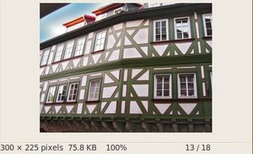

* Moving the slider, trying different threshold, we obtain the following result:

Output:

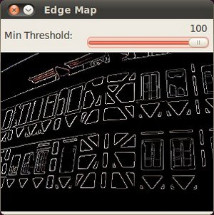

* Notice how the image is superposed to the black background on the edge regions.